Session 7 Labs - Tags

Lab 01 (JSP and JavaBeans)

- Create a new Web Project in NetBeans and copy the form1 and form2 JSP files in the Session 7/Lab 01 folder to your projects Web Pages folder.
- Create two java classes FormBean1 and FormBean2 in a package forms in your projects source packages.
- Copy the code from the FormBean1.txt and FormBean2.txt files from the Session 7/Lab 01 folder, to the two beans you created in the previous step.
- Run form1.jsp and form2.jsp files and observe the results.

Lab 02

Using a JSP to encapsulate the Form Data in a Bean and Forwarding Bean for Processing by a Servlet

- Open your web project and create a new JSP titled PersonInfo. Add a Form control to this page and set the Forms Method to POST and the Action to call itself (PersonInfo.jsp)
- Add a Table with three rows and two columns. Now add two text fields to capture a person’s Id and Name, and a submit Button to the relevant table rows/columns.

- Create a Person class in a package titled beans as shown below:
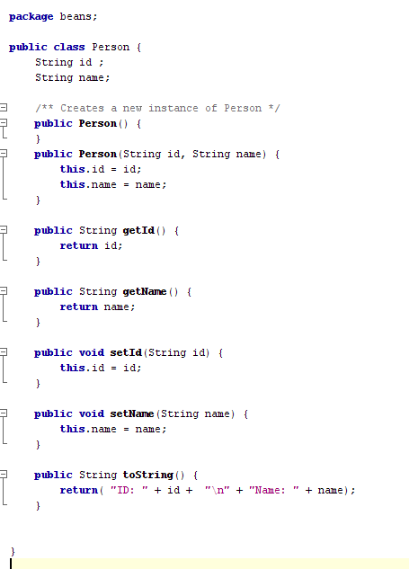
- Add a Use Bean tag to the Form (after the </table> tag) from the JSP Palette in NetBeans as shown below:

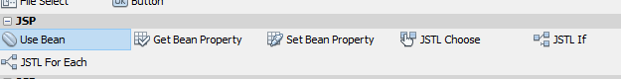

- Set the Bean Tags following properties:

id="person"
scope="request"
class="beans.Person"

- Add the following JSP Tags to the Form after the </table> tag.
Set Bean Property Tag from the JSP Palette as shown below:

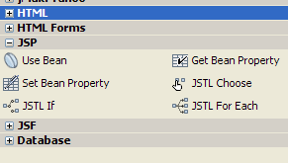

- Set the following attributes for the Set Bean Property:

Property Name="person"
Property Value ="*"/>

- Add a <jsp:forward> Tag to the form and set the following attributes as shown below:

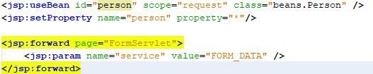

- Add the following Scriplets as shown the JSP page image below:
Add this Scriplet

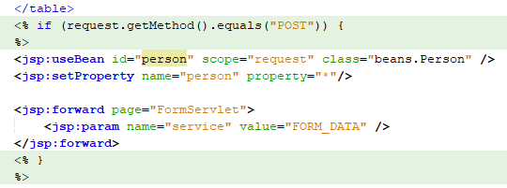
Add this Scriplet

- Create a new Servlet to process the Form Data posted by the JSP as follows:

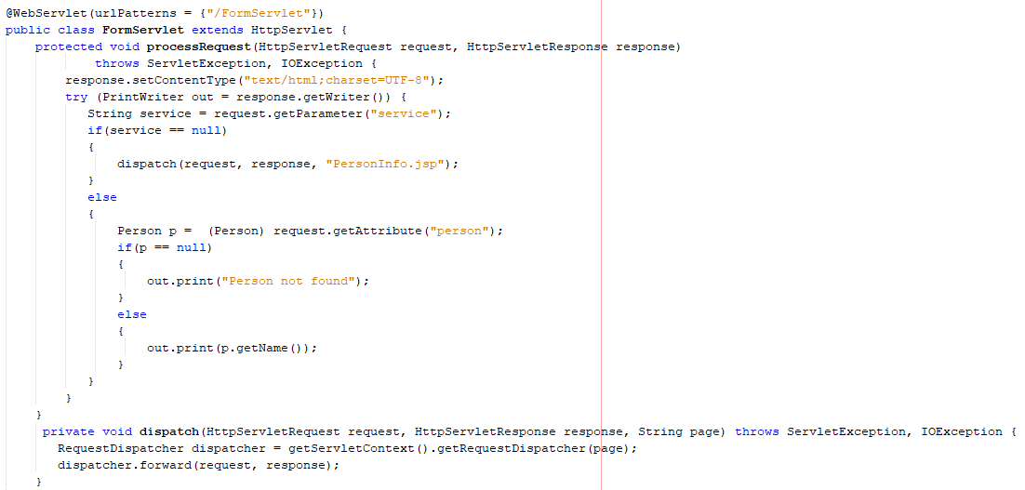

- Run the Servlet and explain to the lecturer how the Form data is processed.
JSP Tag Labs

Lab 03 (Setting Up a Tag Library Descriptor)

- Create a new Web Project in NetBeans titled TagProject
- Right Click on the WEB-INF ->New -> Tag Library Descriptor (shown below)

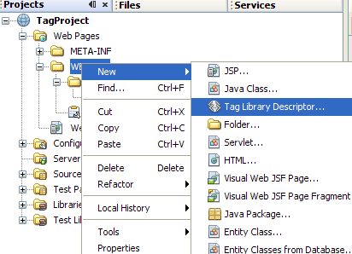

- Give your Tag Library a name (MyTags) -> Click Finish
- Your Tag Library Descriptor (TLD) File is now created and should look like the image below

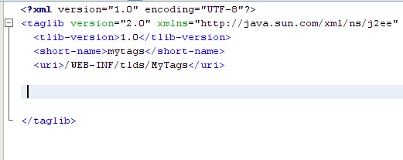

Lab 04 (Creating and using a simple message Tag)

- Create a new package tags in the Source Packages of your project.

- Create a new Class WelcomeTagHandler in this package. Into this class copy and paste the code in the WelcomeTagHandler.txt file located in the
Session 7/Tag Labs/Lab 04 folder.

- Next, add a reference to this Tag in the TLD file (MyTags.tld), by copying and pasting the text in the Welcome Tag Entry.txt file.

- Create a new JSP Welcome and copy the code in the Welcome.txt file and paste it in this JSP. Your JSP should look like the image below

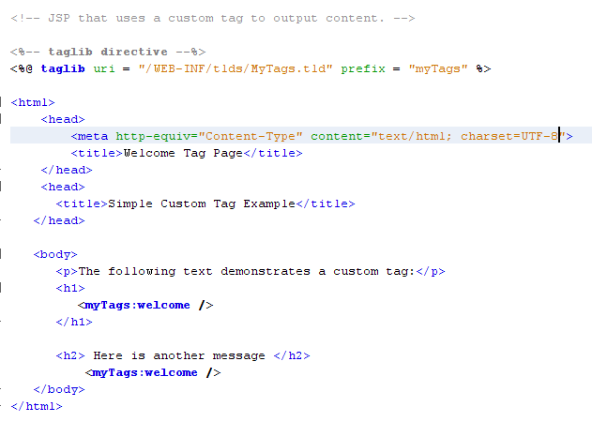

- Run the Welcome.jsp and note the output.

- Modify the Message in the WelcomeTagHandler class, and run the JSP again,

Lab 05 (Creating a Tag with Attributes)

To appreciate how Tags cut down the amount of Java coding in a JSP, lets run a JSP that displays an appropriate greeting depending on the time of day.

- Create a new JSP Greetings1 in your project. Copy the code in the greetings1.txt file located in the Session 7/Tag Labs/Lab 05 folder, and paste it into this JSP.

- Run the JSP and note the greeting.

Let us now use a tag to display the dynamic greeting, which means that our JSP is now free of any Java code, and looks much simpler

- Create a new JSP Greetings2.jsp in your project. Copy the code in the greetings2.txt file located in the Tag Labs/Lab 05, and paste it into this JSP.

- In the tags package you created earlier, create a new class GreetingTag1. Into this class copy and paste the code in the GreetingTag1.txt file located in the Tag Labs/Lab 05 folder .

- Next, add a reference to this Tag Handler in the TLD file, by copying and pasting the text in the Welcome Tag Entry.txt file.

- Run the Greetings2.jsp and note the output. Notice how cleaner this JSP looks when compared to Greetings1.jsp

Lab 06 (Creating a Tag to track number of page hits/session)

If your not convinced that Tags will cut down the amount code in your JSP, let us look at another example. This Tag will help you measure the number of times a person hits your web site during a browsing session.
You might recall writing a JSP earlier (JSP implicit Objects) in the previous session to do this. Open this JSP and examine the amount of Java code contained in it.

- Create a new JSP SessionCount in your project. Copy the code in the SessionCount.txt file located in the Tag Labs/Lab 06 folder, and paste it into this JSP.

- In the tags package you created earlier, create a new class SessionCountTag Into this class copy and paste the code in the SessionCountTag.txt file located in the Tag Labs/Lab 06 folder located in the subject share drive.

- Next, add a reference to this Tag Handler in the TLD file, by copying and pasting the text in the SessionCount Tag Entry.txt file.

- Run the SessionCount.jsp several times to test if it works. Notice how cleaner this JSP looks when compared to the one you wrote earlier.

Lab 07 ( Creating a Tag to track the total number of page hits)

Write a TagHandler class that could be used to keep track of the total number of times a user visits your site.
Create a JSP to use this Tag, and test it to make sure it works. Show the instructor a working solution.
NOTE – You will need an instance of the ServletContext to keep track of all page hits. To get this context use the following code:
ServletContext context = pageContext.getServletContext();

Lab 08 ( Creating a Tag handle posted data in Form fields)

- Create a new JSP FormData1 in your project. Copy the code in the FormData1.txt file located in the Tag Labs/Lab 08 folder, and paste it into this JSP.

- In the tags package you created earlier, create a new class FormDataTagHandler. Into this class copy and paste the code in the FormDataTagHandler.txt file located in the Tag Labs/Lab 08 folder located in the subject share drive.

- Next, add a reference to this Tag Handler in the TLD file, by copying and pasting the text in the FormData1 Tag Entry.txt file.

- Before you run the FormData1.jsp you will need to explicit add the name parameter to the postback URL. To do this right click on this JSP -> Properties. From the Properties Window Select Request Parameters and enter the text ?name=Bill as shown below.

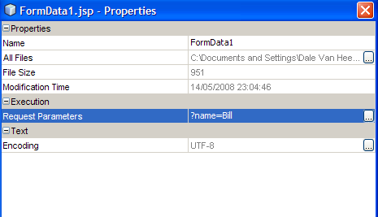

- Run the FormData1.jsp and observer the response.

- Modify the JSP properties to include a Last Name and Email field. To process the data from these fields, modify your Tag Handler class. Note you will also have to modify the Tag entry in the TLD file.

Lab 09 (Creating a Tag to cache Form data across postback)

If a form requires a user to enter data in some mandatory fields, and if the user omits one or more such fields, the form is posted back to the user with the data entered previously completely erased.

- Create a new package forms and create a new class FormBean in this package. Copy the code in the FormBEan.txt file located in the Tag Labs/Lab 09 folder, and paste it into this class.
- Create a new JSP RegForm1 in your project. Copy the code in the RegForm1.txt file located in the Tag Labs/Lab 09 folder, and paste it into this JSP.
- Run this JSP and observe what happens if the user omits to enter one or more of the mandatory fields.

There are a few strategies we could use to maintain the state of the entered fields across post backs to the server.

Strategy 1
- Create a new JSP RegForm2 in your project. Copy the code in the RegForm2.txt file located in the Tag Labs/Lab 09 folder, and paste it into this JSP.
- Run this JSP and observer the initial values in the fields. If the user omits to enter any fields(s), at least the entered data is not lost between postbacks, but it is still not an adequate solutions. Why????

Strategy 2
- Create a new JSP RegForm3 in your project. Copy the code in the RegForm3.txt file located in the Tag Labs/Lab 09 folder, and paste it into this JSP.
- Run this JSP and observe what happens if the user omits to enter one or more of the mandatory fields.
This solution works very well, however your JSP is cluttered with blocks of java code creating a maintenance headache.

Strategy 3 (Using a Tag Handler)
- Create a new JSP RegForm4 in your project. Copy the code in the regForm4.txt file located in the Tag Labs/Lab 09 folder , and paste it into this JSP.
- In the tags package you created earlier, create a new class GetRequestParameterTag. Into this class copy and paste the code in the GetRequestParameterTag.txt file located in the Tag Labs/Lab 09 folder located in the subject share drive.
- Next, add a reference to this Tag Handler in the TLD file, by copying and pasting the text in the GetRequestParameterTag Entry.txt file.
- Run this JSP and observe what happens if the user omits to enter one or more of the mandatory fields.
Compare the this JSP with the one you created earlier and notice how much java code is taken out.

Additional Challenge
Modify the RegForm4.jsp, add a dropdown list of some items , say subscription frequencies (like weekly, monthly, annually) and a set of check boxes for some magazines (Time, Newsweek, Readers Digest, Economist).
Modify your FormBean to accommodate the additional data.
Use the Tag Handler to maintain the user selections for the new fields across page postbacks

